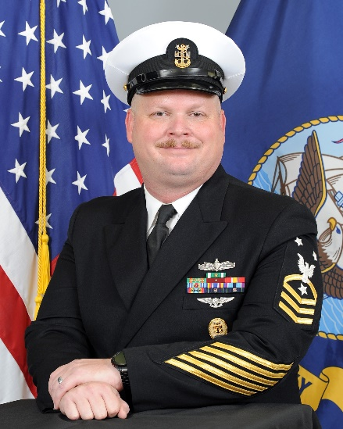
Master Chief Barman is a native of Jacksonville, FL, and enlisted in the Navy on July 16, 2002. After Basic Training in Great Lakes, IL he reported to Naval Air Technical Training Center Pensacola for AT "A” School and was assigned to USS JOHN F. KENNEDY (CV-67) Mayport, FL for his first tour as an AT ”I” technician. He completed a deployment to FIFTH Fleet for Operation Enduring Freedom in 2004 and served until the ship decommissioned in March 2007.
In July 2007, he converted to ET and reported to USS MASON (DDG-87) Norfolk, VA after completing AN/SPS-67 Radar “C” school. He was the Combat Electronics Division RADAR/Navigation Workcenter supervisor. Deploying to FIFTH Fleet in 2008 to support Operation Iraqi Freedom and Anti-piracy operations.
Reported to NAS Key West, FL in December of 2009 after completing AN/GPN-27 “C” School, served as the Radar Branch Supervisor for Ground Electronic Maintenance Division.
In June 2013 he reported to USS MESA VERDE (LPD-19) after completing AN/UPX 29 IFF “C” School. While assigned served as Combat Missile Division Leading Petty Officer and the Combat Electronics Division Leading Chief Petty Officer after being selected to Chief in September 2015. Completed on 2014 deployment to FIFTH Fleet for Operation Inherent Resolve, and a 2017 Deployment to SIXTH Fleet. In 2018 he reported to TOCRON Ten and served as the Senior Enlisted Leader for the command.
He was selected to the Command Senior Chief program in February 2021 and assigned to PCD Cooperstown (LCS-23) until April 2022, then reassigned to USS Billings (LCS-15) Gold Crew where he served as the Command Senior Chief from until March 2023. He was selected for Master Chief in 2023 and is currently serving as the Command Master Chief onboard NSA Lakehurst part of Joint Base McGuire-Dix-Lakehurst.
Master Chief Barman is a graduate of the Senior Enlisted Academy Class 236 Gold. His personal achievements include Enlisted Surface Warfare, Enlisted Aviation Warfare, and Enlisted Information Warfare. His personal awards include the Navy and Marine Corps Commendation Medal (3), Navy and Marine Corps Achievement Medal (5), and various unit and campaign awards.

