CSM James W. Van Zlike

Army Support Activity-Dix Command Sgt. Major  
UNITED STATES ARMY

Command Sergeant Major James W. Van Zlike is a native of Junction City, Kansas. He entered the Army in July 2001 and attended Basic Combat Training (BCT) at Ft. Benning, GA. Upon graduating BCT, CSM Van Zlike attended Advanced Individual Training at Ft. Gordon, GA where he was awarded the MOS of 31F, Network Switching Systems Operator/Maintainer. He later attended the 11B, Infantryman, MOSQ transition course at Ft. Benning, GA in 2007.

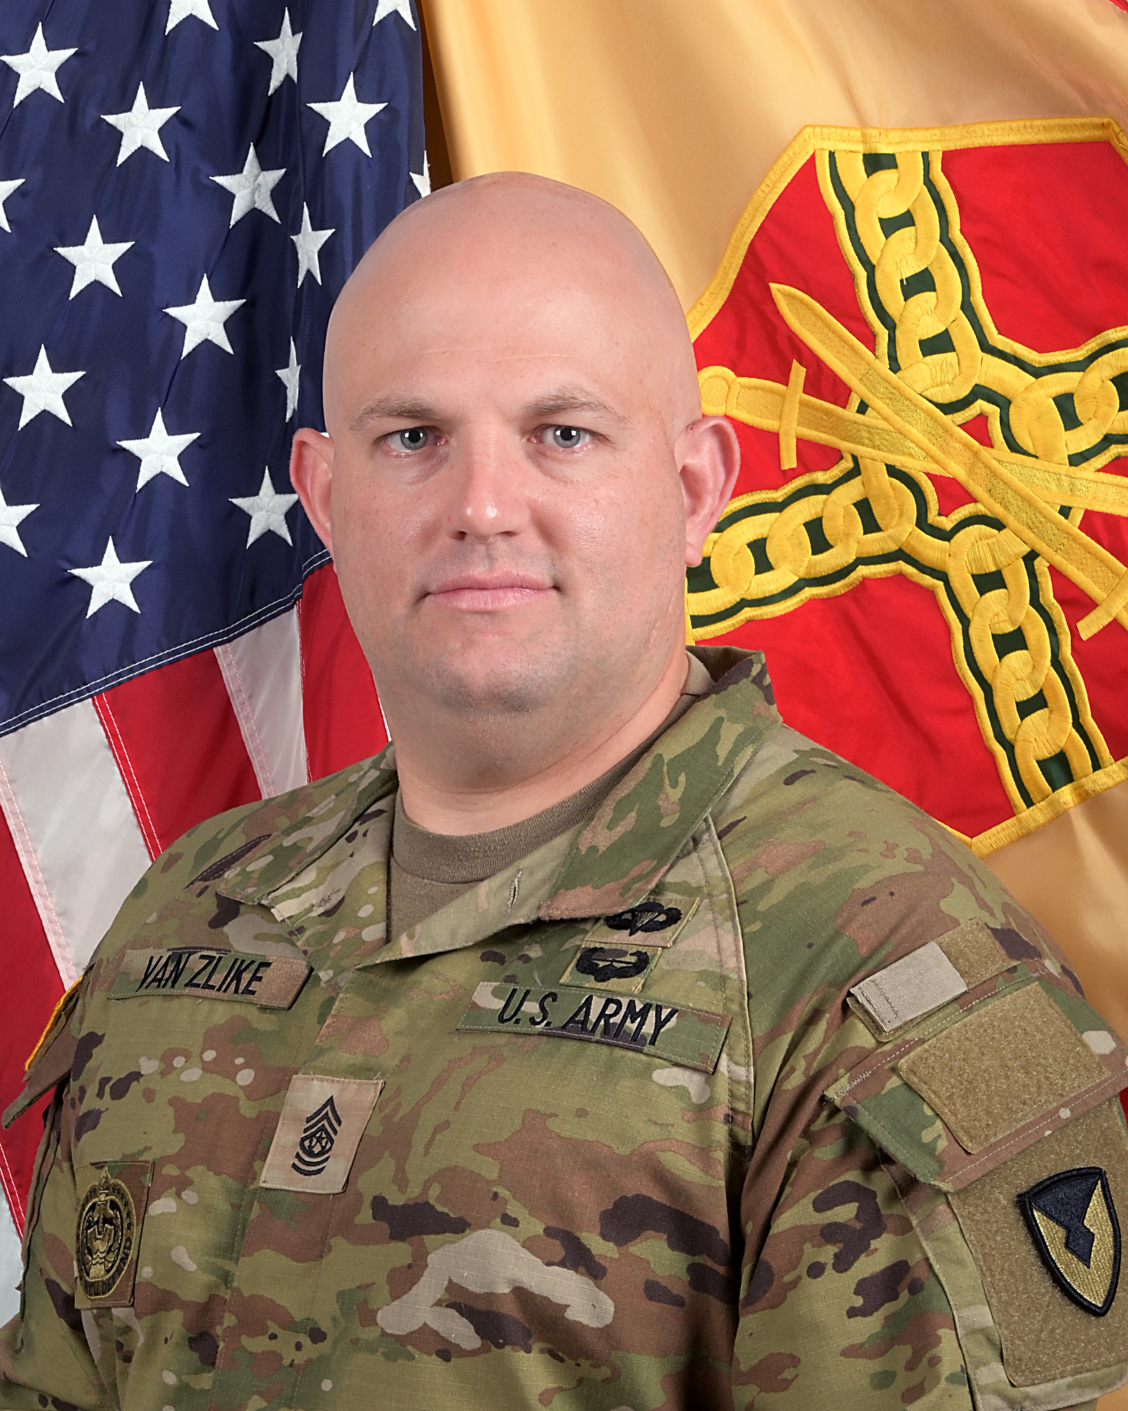

His duty assignments include: Communication and Electronics technician, HHC, 17th Signal Battalion, 22nd Signal Brigade, Kitzingen, Germany including a deployment to Baghdad, Iraq during OIF I; Node Center Team Leader, 534th Signal Company, 4th Special Troops Battalion, 3rd Brigade Combat Team, 4th Infantry Division, Ft. Carson, CO; Senior Drill Sergeant, D Company, 2/377th Infantry Regiment, 1st Brigade, 95th Infantry Division, Ft. Sill, OK; Platoon Sergeant, 404th Signal Company, 77th Sustainment Brigade, JBMDL, NJ; 1SG, Headquarters Company, NETCOM, Ft. Huachuca, AZ; G3/5/7 Sergeant Major, 311th Signal Command (Theater), Fort Shafter, HI and is the incoming Command Sergeant Major of United States Army Support Activity Fort Dix, NJ.

CSM Van Zlike’s military schools include Drill Sergeant School, Infantry MOSQ Transition Course, Maneuver Senior Leaders Course, Master Resilience Training Course, Air Assault Course, Rappel Master Course, Battle Staff Noncommissioned Officer Course, Basic Airborne Course, the Force Management and Manpower Course, and the United States Sergeant Major Academy (Class 69). CSM Van Zlike holds a Bachelor of Science in Information Systems Security from the University of Phoenix and a Masters of Public Administration from the University of Texas – El Paso.

CSM Van Zlike’s awards and decorations include the Meritorious Service Medal (2 OLC), Army Commendation Medal (3 OLC), Army Achievement Medal (4 OLC), Army Good Conduct Medal (2nd Award), Army Reserve Components Achievement Medal (2nd Award), Iraq Campaign Medal (2 Campaign Stars), Global War on Terrorism Expeditionary Medal, Global War on Terrorism Service Medal, Armed Forces Reserve Medal (1 Bronze Hourglass), Meritorious Unit Citation, Drill Sergeant Identification Badge, Air Assault Badge, Parachutist Badge, Silver German Armed Forces Proficiency Badge.

CSM Van Zlike is married to Lindsay Van Zlike and they have two children, a daugher Liberty, and a son James.