LIEUTENANT COLONEL THOMAS J. HORAN
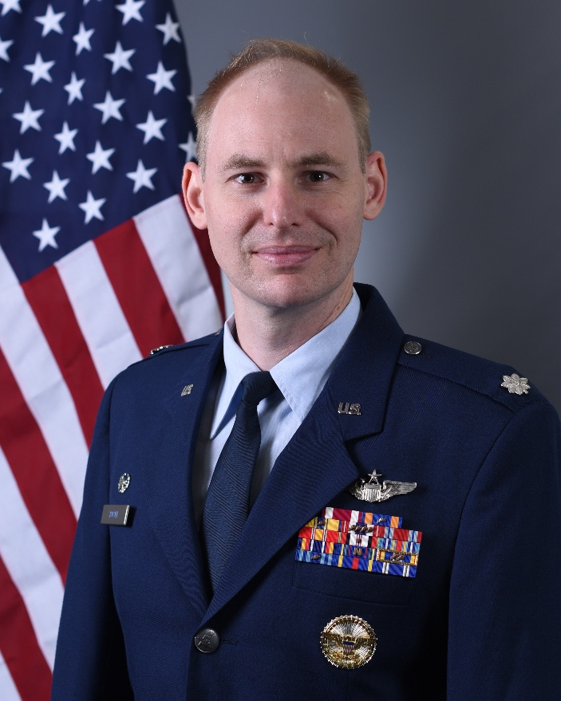
Lt Col Thomas J. Horan is the Commander of Air Mobility Command Test & Evaluation Squadron (AMCTES), Joint Base McGuire-Dix-Lakehurst, NJ. He leads 65 personnel in planning and executing operational tests and evaluations for all Air Mobility Command aircraft and their associated requirements. AMCTES performs over 40 test events annually, determining and communicating the operational impact of fielding new capabilities for the Command’s $150B fleet.

Lt Col Horan was commissioned in 2008 after graduating from Purdue University. After completion of pilot training at Laughlin Air Force Base (AFB), Texas, in 2011, Lt Col Horan began his flying career at McConnell AFB, Kansas. His previous positions include Artificial Intelligence/Machine Learning (AI/ML) Program Manager, Chief of Wing Weapons & Tactics, KC-10A Formal Training Unit Instructor Pilot, and Flight Commander. He is a graduate of the United States Air Force Weapons School.

Lt Col Horan is a pilot with more than 3,000 flying hours, primarily in tanker aircraft. He has broad experience in worldwide air refueling and mobility operations, as well as defense acquisitions, with deployments in support of Operations NEW DAWN, ENDURING FREEDOM, RESOLUTE SUPPORT, and INHERENT RESOLVE. He is a certified acquisition professional in the Test & Evaluation and Engineering & Technical Management functional areas. Prior to AMCTES, Lt Col Horan was the Director of the AI/ML Portfolio, Defense Innovation Unit, Office of the Secretary of War.

EDUCATION
2008 Bachelor of Science in Aeronautical & Astronautical Engineering, Purdue University, Ind.
2009 Air & Space Basic Course, Maxwell AFB, Ala.
2012 Master of Engineering in Systems Engineering, Pennsylvania State University
2012 Squadron Officer School by Correspondence
2015 KC-135 Weapons Instructor Course, United States Air Force Weapons School, Nellis AFB, Nev.
2015 Squadron Officer School, Maxwell AFB, Ala.
2019 Air Command & Staff College by Correspondence
2021 Distinguished Graduate, Master of Military Operational Art & Science, Air Command & Staff College, Maxwell AFB, Ala.
2025 Air War College by Correspondence

ASSIGNMENTS
- June 2009 – February 2011, Student, Specialized Undergraduate Pilot Training, Laughlin AFB, Texas
- March 2011 – August 2011, Student, KC-135R Pilot Initial Qualification, Altus AFB, Okla.
- September 2011 – December 2015, KC-135R/T Instructor Pilot, Flight Commander and Weapons Officer, 349th Air Refueling Squadron, McConnell AFB, Kan. (July 2014 – November 2014, Assistant Director of Operations, 340th Expeditionary Air Refueling Squadron, Al Udeid Air Base, Qatar)
- January – June 2016, Student, KC-10A Aircraft Commander Initial Qualification, Joint Base McGuire-Dix-Lakehurst, New Jersey
- June 2016 – July 2020, Chief of Wing Plans & Programs, KC-10A Formal Training Unit Instructor Pilot, 305th Air Mobility Wing, Joint Base McGuire-Dix-Lakehurst, New Jersey
- July 2020 – May 2021, Student, Air Command & Staff College, Maxwell AFB, Ala.
- June 2021 – September 2024, AI/ML Program Manager, Defense Innovation Unit, Office of the Undersecretary of Defense (Research & Engineering) later Office of the Secretary of Defense, Mountain View, Ca.
- October 2024 – February 2026, Director, AI/ML Portfolio, Defense Innovation Unit, Office of the Secretary of War, Mountain View, Ca.
- March 2026 – Present, Operations Officer, later Commander, Air Mobility Command Test & Evaluation Squadron, Joint Base McGuire-Dix-Lakehurst, New Jersey

SUMMARY OF JOINT ASSIGNMENTS
- June 2021 – February 2026, Program Manager and AI/ML Portfolio Director, Defense Innovation Unit, Office of the Undersecretary of Defense (Research & Engineering) later Office of the Secretary of War, Mountain View, Ca, as a major and lieutenant colonel

FLIGHT INFORMATION
Rating: Senior Pilot
Flight hours: More than 3,000 including more than 900 combat hours
Aircraft flown: T-6A, T-1A, KC-135R/T, KC-10A, KC-46A

MAJOR AWARDS AND DECORATIONS
Defense Meritorious Service Medal
Meritorious Service Medal
Air Medal with 5 oak leaf clusters
Air Force Commendation Medal with one oak leaf cluster
Combat Readiness Medal
Nuclear Deterrence Operations Service Medal with “N” device
NATO Non-Article 5 Medal

EFFECTIVE DATES OF PROMOTION
Second Lieutenant March 1, 2009
First Lieutenant March 1, 2011
Captain March 1, 2013
Major October 1, 2018
Lieutenant Colonel November 1, 2023

(Current as of March 2026)

